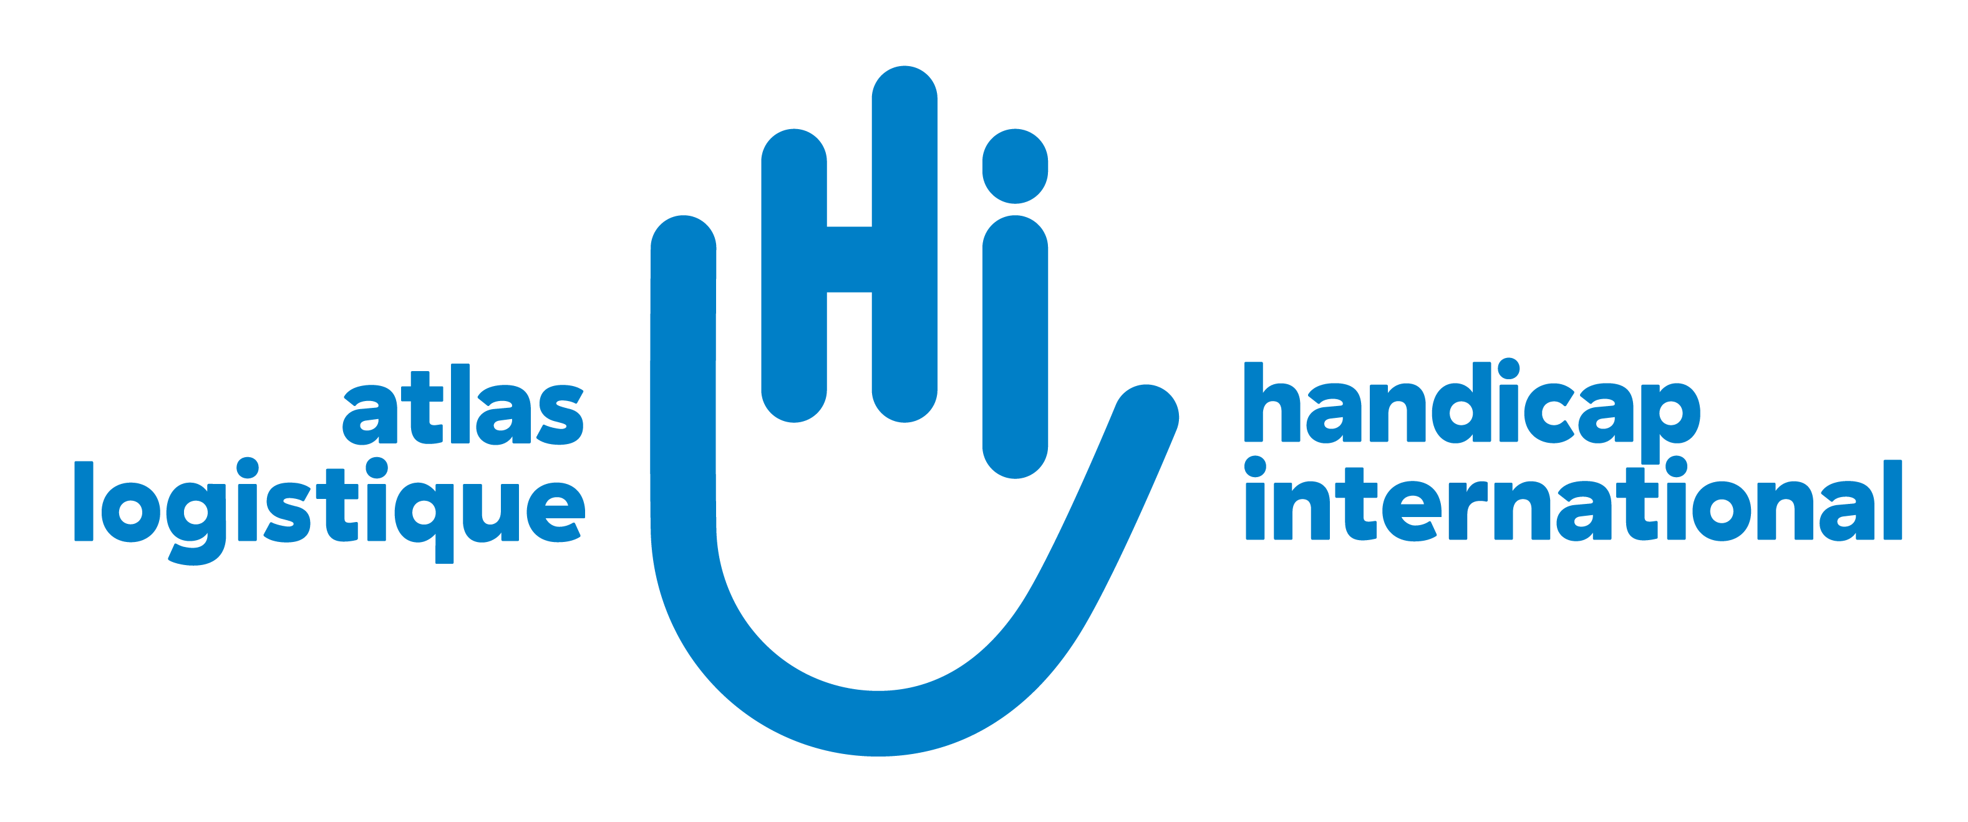

**NOTICE OF OPEN AND CONTINUOUS CALL FOR QUOTATION**

**REF No : OCCQ/GAZ/0001/2025**

**Call for transportation** **services** **offers in Gaza**

Handicap International/Humanity & Inclusion with its Atlas Logistique (HI/AL) project, proposes to provide free road transportation services to humanitarian organisations delivering aid in Gaza. To this end, HI/AL launches a call for open and continuous quotations for the provision of transport services in the whole of Gaza.

HI/AL intends to award contracts to qualified suppliers for truck chartering services on the basis of transport requests from its humanitarian services partners.

**General Instructions**

Offers should be submitted by origin, destination, type of truck (delivery van, flatbed truck, refrigerated truck, etc), payload.

**Offers should be sent to** [atlas.transport@palestine.hi.org](mailto:atlas.transport@palestine.hi.org) **before 31 March 2025 EoB.**

**Attachment(s):**

* Call for quotation
* ACOC explanatory note
* Supplier information form
* Quotation sheet template

**Please download all documents here: link**

**Offers should be sent to** [atlas.transport@palestine.hi.org](mailto:atlas.transport@palestine.hi.org) **before 31 March 2025 EoB.**